TCC web service for Mobile App API Proposal

Swagger

#[Swagger Editor](http://swagger.io/swagger-editor/)   
#Swagger Code Gen

#Jax-RS

1. TCC environment constrains :
   1. [WebLogic Server 11gR1 PS5 (10.3.6)](https://en.wikipedia.org/wiki/Oracle_WebLogic_Server) (maybe, need confirmation)
   2. Java 7
2. Expected Development Workflow
   1. Edit API spec with YAML on Swagger Editor([which can be launched up locally](http://swagger.io/docs/swagger-tools/#using-the-editor-on-a-local-machine-3))
   2. Swagger Code Gen generate server stub
   3. Implement server side logic.
   4. Swagger Code Gen generate client libraries
   5. Implement client side logic.
3. Advantage
   1. Maintain YAML file for API spec
   2. Auto Documentation.
   3. Generate server stub and client libraries,
   4. Leave the API spec to tools, we concentrate on implantation.
   5. [Postman API test](https://www.getpostman.com/docs/importing_swagger) intergration
   6. [Development of the OpenAPI Specification (OAS) is overseen by the Open API Initiative, an open source collaborative project of the Linux Foundation](https://en.wikipedia.org/wiki/OpenAPI_Specification#cite_note-2)

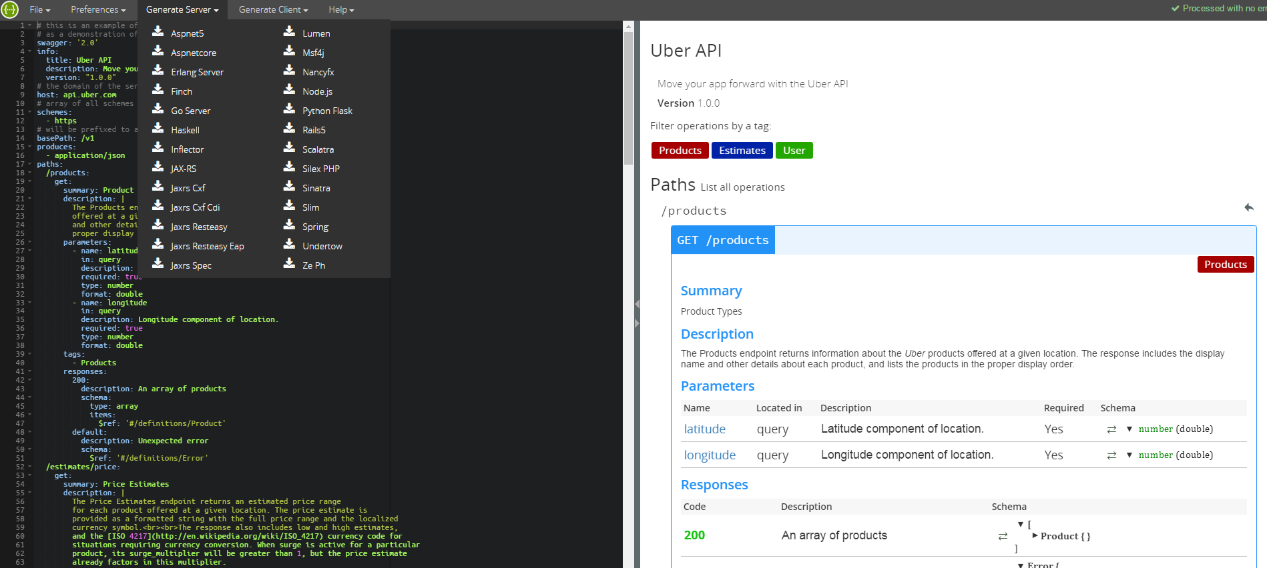

Local development preparation

1. Get maven project from Swagger Editor



1. [gradle init] to get dependencies

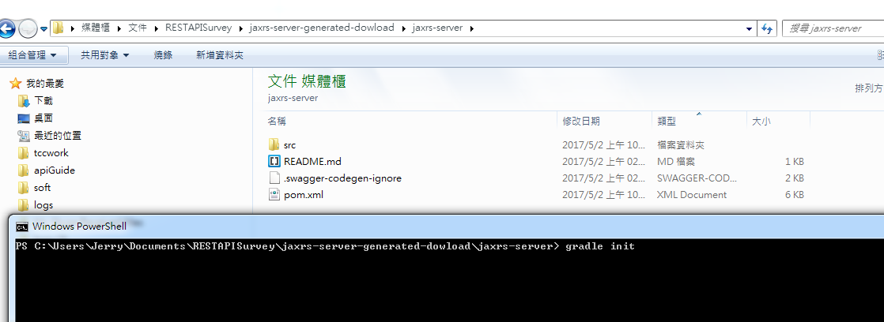

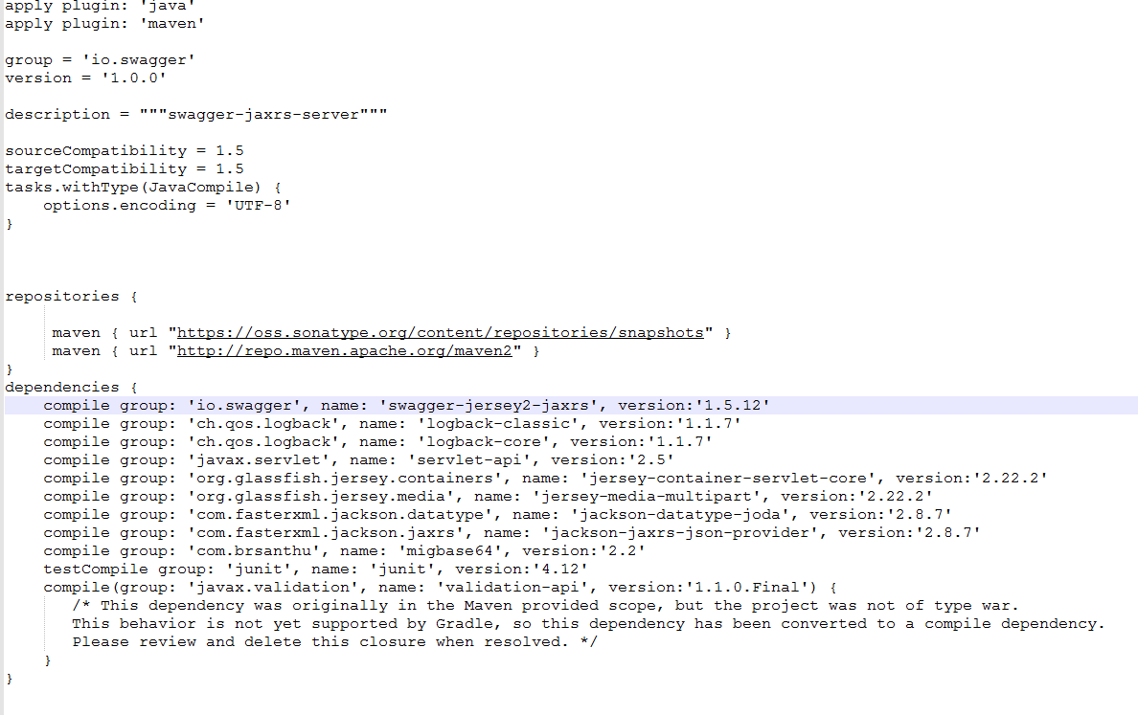

1. Add dependencies to local build.gradle

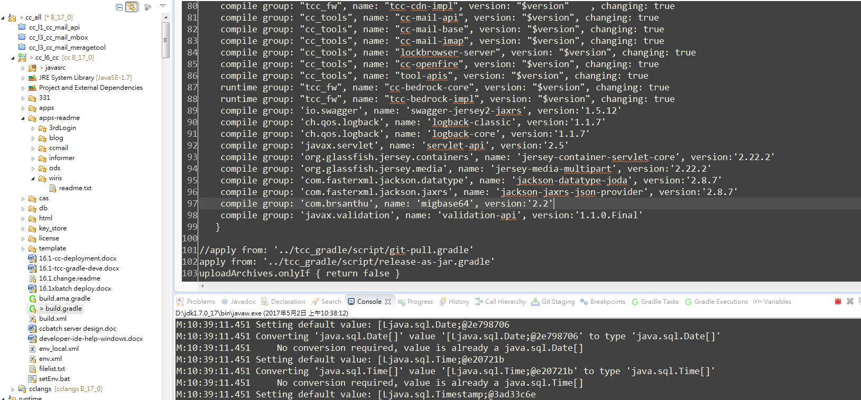

1. Get pom.xml from Swagger Code Gen, download all JARs using Maven.  
   mvn dependency:copy-dependencies -DoutputDirectory=OUTPUT_DIR
2. Add Downloaded JAR to runtime directory  
   D:\tccwork\newfeature\deployment\apps\weblogic\applications\ccwebapp\WEB-INF\lib
3. Runtime Web.xml

D:\tccwork\newfeature\deployment\apps\weblogic\applications\ccwebapp\WEB-INF\web.xml

Add lines:

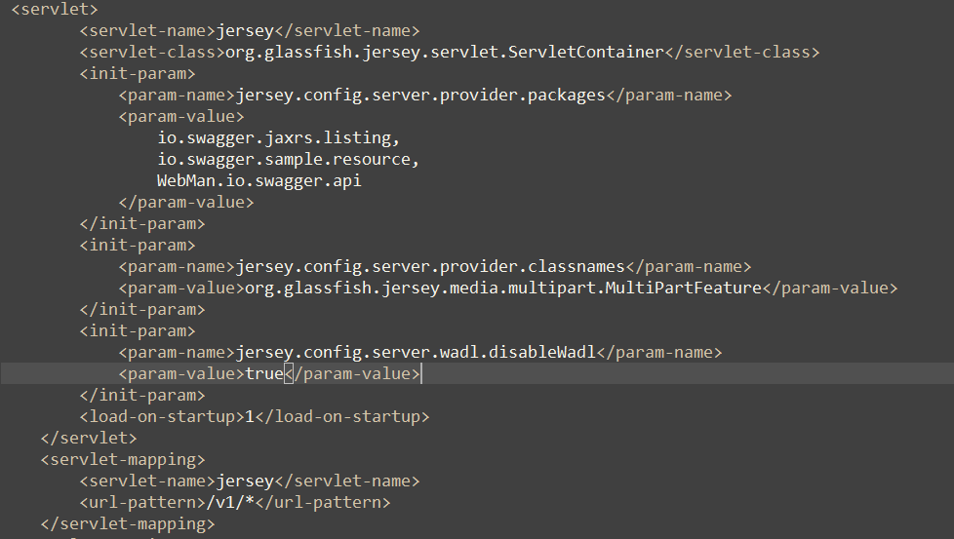

1. httpd.conf add lines

ProxyPass /v1 http://localhost:8100/v1

ProxyPass /v1/* http://localhost:8100/v1/*

Running up sample -- Uber API

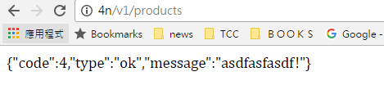

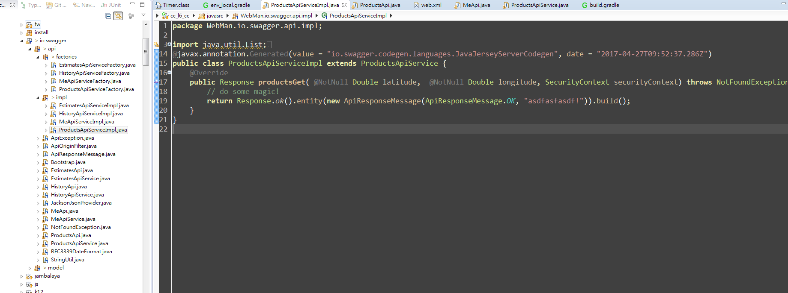

[Customizing the generator](https://github.com/swagger-api/swagger-codegen#customizing-the-generator)

1. Download or clone project from [GitHub](https://github.com/swagger-api/swagger-codegen)
2. We need Parameter from request, so modify the following files.

*The .mustache files is the templates for Swagger Code Gen.*

modules\swagger-codegen\src\main\resources\JavaJaxRS\apiServiceImpl.mustache

modules\swagger-codegen\src\main\resources\JavaJaxRS\api.mustache

modules\swagger-codegen\src\main\resources\JavaJaxRS\apiService.mustache

Replace parameter from **SecurityContext** to **ContainerRequestContext**

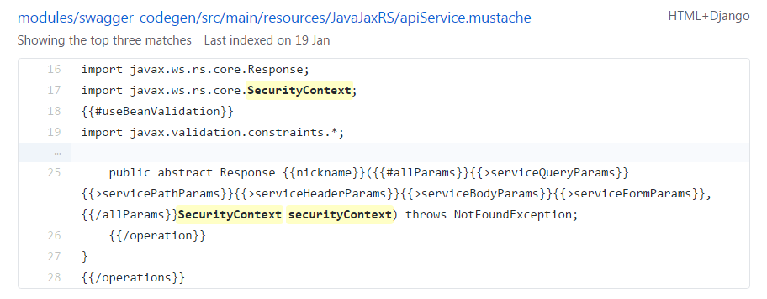

1. [Getting Started](https://github.com/swagger-api/swagger-codegen#getting-started) locally
2. [Customizing package](https://github.com/swagger-api/swagger-codegen#customizing-the-generator)